NAME: circle precept: login ID: P01 P01A P02 P02A P03

COS 226 Midterm Exam, Spring 2010
This test is 10 questions, weighted as indicated. The exam is closed book, except that you are allowed to use a one page cheatsheet. No calculators or other electronic devices are permitted. Give your answers and show your work in the space provided. Put your name, login ID, and precept number on this page (now), and write out and sign the Honor Code pledge before turning in the test. You have 80 minutes to complete the test.
"I pledge my honor that I have not violated the Honor Code during this examination."
1 /5 2 /5 3 /10 4 /5 5 /5 6 /10 7 /10 8 /10 9 /10 10 /20 11 /10 TOTAL /100
1. Partitioning (5 points). Give the result of partitioning the array with standard Quicksort partitioning (taking the N at the left as the partitioning element).
N O P A R T I T I O N I N G B U G S
G O B P G R N T I T N O N N
2. Estimating running time (5 points). Suppose that you run the code fragment below (generate and then Mergesort an array of random double values) for N= 10,000,000 and observe that it takes 5.3 seconds.
Double[] a = new Double[N]; for (int i = 0; i < N; i++) a[i] = Math.random(); Merge.sort(a);
Assuming you have enough memory which of the following is a reasonable prediction of its running time (in seconds) for N= 1,000,000,000?
A. 53 seconds.
B. 340 seconds
C. 530 seconds.
D. 680 seconds
E. 1060 seconds
F. 5300 seconds
3. Social networking (10 points). Suppose that a social networking website FRIENDS needs to support two operations: (i) declare A and B to be friends (thus making all of As friends and all of Bs friends friends of each other); and (ii) determine whether A and B are friends.
Which APIs should FRIENDS use to support these operations (circle two)?
A. Queue.
B. Union-find.
C. Stack.
D. Priority queue.
E. Symbol table.
F. Randomized queue.
Give the worst case order of growth of the running time that FRIENDS can guarantee for M operations, where N is the number of people listed on the website (circle one).
G. N log M.
H. M log N.
I. N log N.
J. M.
K. N log* M.
L. M log* N.
In one or two sentences, justify your answer (describe how FRIENDS should implement the two operations).
Use a symbol table to map names to ids. For (i), union(A, B). For (ii), find(A, B).
4. Sorting algorithms (5 points). Match each of the types of input files described at right below with the most appropriate sorting algorithm (as presented in lecture and in the book) by writing the letter corresponding to an algorithm in the blank to the left of the corresponding file type. You should use each letter only once (and leave two letters unused).
A. Mergesort __F___ Huge file, not many different key values
B. Quicksort __E___ Huge records
C. Heapsort __D___ Several new records appended to huge sorted file
D. Insertion sort __B___ Huge file of double values, not much extra space available, speed matters
E. Selection sort __A___ Huge file, speed and stability matter
F. 3-way quicksort
G. Shellsort
5. Random sort (5 points). Operating under court order, a certain computer company recently decided to randomly assign the order of browsers for customers to choose by using a system sort with the following broken compareTo() implementation .
public int compareTo(Browser b) { if (Math.random() < 0.5) return -1; else return +1; }
Assume that (since the list of browsers is short) the system uses our version of insertion sort for the task. Where would you prefer that your company's browser be in the list given as input to the sort?
A. At the beginning.
B. Second from the beginning.
C. Doesn't matter, since the sort randomizes the array.
D. Next to last.
E. At the end.
F. Either at the beginning or second from the beginning.
6. Mergesort (10 points). Consider the following implementation of recursive mergesort:
public class Merge
{ public static void sort(Comparable[] a, Comparable[] aux, int lo, int hi) {
if (hi <= lo) return; int mid = lo + (hi - lo) / 2; sort(a, aux, lo, mid); sort(a, aux, mid+1, hi); merge(a, aux, lo, mid, hi); // merges 2 sorted subarrays into a[lo..hi].
System.out.print(lo + " " + hi + " "); for (int i = lo; i <= hi; i++) System.out.print(a[i] + " "); System.out.println(); }
public static void sort(Comparable[] a)
{ int N = a.length; Comparable[] aux = new Comparable[N]; sort(a, aux, 0, N-1);
} }
Note that the last three lines of the recursive method have been instrumented to print the values of the indices and the contents of the array. The output produced by these methods when invoked by the following code appears below in scrambled order:
Character[] a = { 'z', 'y', 'x', 'w', 'v', 'u', 't' , 's' , 'r' }; Merge.sort(a);
A. 0 2 x y z
B. 3 4 v w
C. 0 4 v w x y z
D. 5 8 r s t u
E. 0 8 r s t u v w x y z
F. 0 1 y z
G. 7 8 r s
H. 5 6 t u
Give the order in which these lines actually appear in the output by writing one letter in each of the blanks below (the last one is filled in for you).
__F__ __A__ __B__ __C__ __H__ __G__ __D__ __E__
7. LLRB insertion (10 points). The following diagram shows a left-leaning red-black tree
Thick lines are red links.
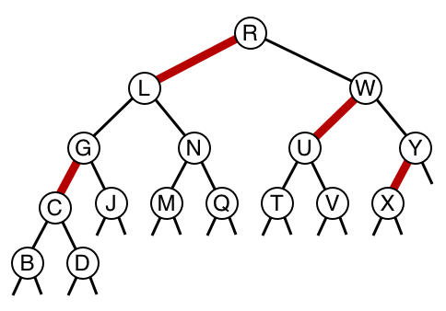
A. (2 points) Draw the tree that results after E is inserted.
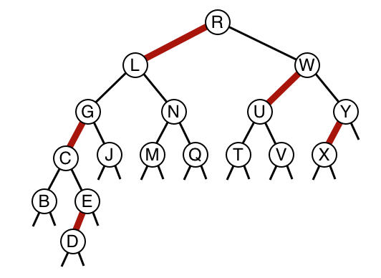
B. (8 points) Draw the tree that results after F is inserted into your tree from Part A. Hint: You might find it easiest to convert to the 2-3 tree representation, then do the insertion, then convert back to the red-black tree representation.
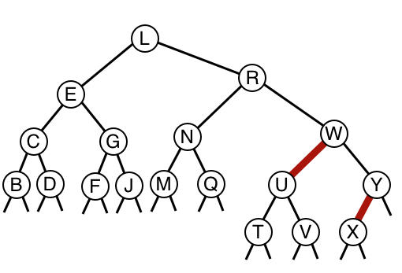
8. Heap operations (10 points). Consider the following max-heap:
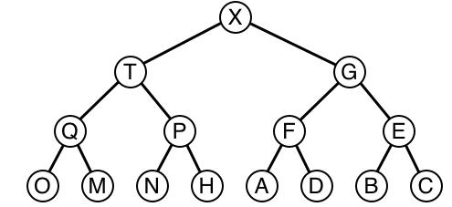
A. Draw the result of inserting Z.
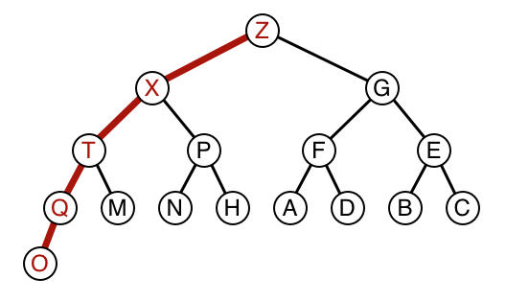
B. Draw the result of deleting the maximum from the original max-heap shown above (before Z has been inserted).
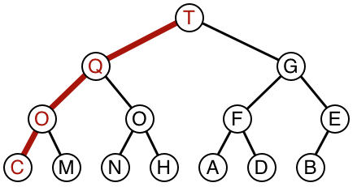
9. Linear probing (10 points). Give the result of inserting the following keys P R O B I N G into an empty linear probing hash table of size M = 7, using the hash function f(x) = i % 7, where x is the ith letter of the alphabet.
x P R O B I N G
i 16 18 15 2 9 14 7 f(i) 2 4 1 2 2 0 0
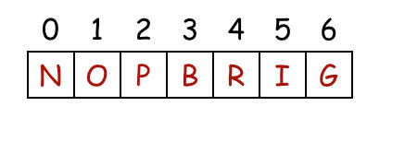
10. 7 sorting algorithms (20 points). The leftmost column is the original input of strings to be sorted, and the rightmost column is the sorted result. The other columns are the contents at some intermediate step during one of the 7 sorting algorithms listed below. Match up each algorithm by writing its letter under the corresponding column. Use each letter exactly once.
rush abba blue abba fixx abba neyo zman abba korn acdc cars blue inxs acdc korn yani acdc fixx blue devo cars korn beck fixx yoyo beck inxs beck enya devo rush blue inxs tatu blue cars cars fixx dido cars cake cars styx cake enya cake fuel enya devo cars enya ween cars devo devo inxs fixx enya cher devo seal cher fuel epmd korn fuel fuel devo fuel lons devo tatu cher moby inxs blue dido lons kiss dido styx inxs rush korn moby doom mims nofx doom blue dido styx moby styx enya blue pras enya moby fuel tatu muse tatu epmd moby rush epmd abba doom abba rush abba rush abba neyo fixx muse kiss muse seal dido muse muse muse fuel seal enya seal styx muse seal cher mims inxs dido lons dido tatu seal tatu dido fuel kiss beck fixx beck acdc acdc fixx beck beck korn kiss neyo kiss beck beck kiss kiss inxs lons acdc korn acdc doom kiss korn acdc acdc mims yani moby yani kiss yani yani epmd cars moby nofx muse nofx nofx doom nofx nofx korn muse doom pras doom pras nofx styx doom doom neyo pras mims pras yani pras pras pras blue nofx yoyo seal yoyo yoyo yoyo yoyo cake moby pras ween nofx ween ween cake ween rush fixx rush zman tatu zman zman neyo zman zman abba seal neyo rush neyo neyo ween neyo ween enya styx cake yani cake cake zman inxs yoyo cake tatu epmd ween epmd epmd cher moby yani epmd ween cher zman cher cher epmd fuel seal cher yani mims styx mims mims lons mims styx devo yoyo lons yoyo lons lons mims lons tatu dido zman
_B__ _C_ _F__ _A__ _E_ _D__ _G_
A. Bottom-up mergesort
B. Shellsort
C. Insertion sort
D. Quicksort (with no random shuffle)
E. Selection sort
F. Top-down mergesort
G. Heapsort 11. Interval clusters (10 points). Consider the following data type, for intervals on the line:
public class Interval implements Comparable<Interval>
{ private final int left; private final int right;
Interval(int left, int right) { this.left = left; this.right = right; }
public int compareTo(Interval b) { return this.left - b.left; } }
For a particular application, clusters of intervals are of importance. To find clusters, replace any pair of intervals that intersects (by even an endpoint) by the union of the two intervals, continuing until all intervals do not intersect. For example, the following set of intervals has 3 clusters:
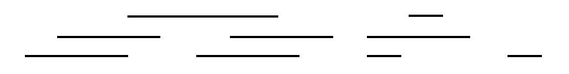
Note that you are guaranteed to have Intervals with non-negative numbers. Given an array of intervals, how many clusters are there? The brute-force algorithm is quadratic, but an enterprising COS226 student figured out a way to find the number of clusters in an array of intervals in linearithmic time, with the following code to be added to Interval.
public static int count(Interval[] a)
{
Arrays.sort(a);
int cnt = 1;
int max = a[0].right;
for (int i = 1; i < a.length; i++)
{
// "Missing" line of code
if (a[i].left > max) cnt++;
if (a[i].right > max) max = a[i].right;
}
return cnt; }
In the space below, write the one line of code that is missing.

